Social Studies 10-1: Unit 4 Module
Impacts of Globalization

In this part of the course you will be a asked to ponder, research and analyse information so you can answer the following questions:

What are human rights?
How are ideas about human rights and democracy related?
How are globalization, human rights and democracy related?

Key Terms:

basic needs:
inalienable:
human trafficking:

Assignment: Related Issue IV Vocabulary

Watch: Quality of Life

Use a dictionary, your textbook or the internet to understand and record the meanings of each of the following terms.

1. Standard of Living

2. Quality of Life

3. NGO

4. Genocide

5. Authoritarian

6. Refugee

7. Grassroots organization

8. Entrepreneur

9. Genetically modified

10. Global Citizenship

11. Civic Responsibilities

12. Boycott

13. Responsible Citizen

14. Gross domestic product

15. Per capita income

16. GNI

17. Disparity

First, read Chapter 13, Chapter 14, Chapter 15 and Chapter 16 in the online textbook. Then complete the following assignment.

Assignment:
To what extent should you, as a citizen, respond to globalization?


Complete the following questions for inquiry and activities for Chapters 13-16. Answer each question in full sentence answer form (unless stated otherwise), and in as much detail as possible.

Chapter 13: To what extent have democracy and human rights shaped-and been shaped by-globalization?

- Read page 310. Explain what rights the Great Law of Peace and the American Constitution outlined, and why each is often considered a milestone in the evolution of human rights.

- Read page 311. Take point form notes on the Universal Declaration of Human Rights. Make sure that your notes include the six categories of human rights, with a brief description of each category.

- Take point form notes on the Canadian Charter of Rights and Freedoms. Make sure your notes include the seven categories-and provide a brief description of each category.

- In sentence format, compare and contrast the two Declarations: How are they similar/ how are they different?

- Analyze the three quotations on page 314. Remember that when analyzing a source; try to put the main idea into your own words and think of the values and policies that the person would support. Last, review your analysis and the figure on page 13-9 and create a mind-map showing how these four items are linked.

- Read page 317 and provide two examples that support the following statement: Economic Globalization presents both challenges and opportunities.

- Explain how cultural imperialism is both different and the same as historical imperialism. ( Page 319 )

- Activists around the world have been successfully using the internet to launch global campaigns against corporations in an effort to promote human rights. List and explain three examples of this (only two are mentioned in the text). Also explain how, on the other hand, the limitations that the Internet has in promoting human rights.

Chapter 14: Global Awareness
- Create a two column chart labeled,” Ripple Effects of Globalization”. Label one column “Challenges “and label the other column “Opportunities. As you read pages 326-328, take point form notes to complete your chart.

- Examine Figure 14-4 on page 329. Describe and explain the geographic patterns that are revealed by the data. The highest ranked country on the list scored only 5.53. What do you think this means?

- Read pages 329-331. After reading this section, answer the following questions: What effects does globalization have on the quality of life of women? Are these effects mostly positive or negative?

- Read pages 339-340. Explain the three different strategies that are sometimes used to promote human rights, including the logic behind each strategy.

Chapter 15: Global Connections
- Read pages 350-351 about Oil in Africa, Iraq, Oil, and War and Alberta and Oil. In two- three sentences explain how the global need for oil affected/ affects people in each of these cases.

- Read pages 355-358. What is a pandemic? In what ways does globalization facilitate the spread –and prevention-of pandemics?

- Read pages 359-363 In point form, answer the following questions:
a) What civic responsibilities do consumers have in relation to globalization?

b) What civic responsibilities do businesses have in relation to globalization?

c) What civic responsibilities do governments have in relation to globalization?

Chapter 16: The Global Citizen
- In point form, list some of the qualities of a global citizen.

- List four actions that a global citizen takes-and provide an example of each.

- Explain the aims of civil society. Also provide an example of an organization and its actions that work to carry out these aims.

CHINA BLUE: Introduction
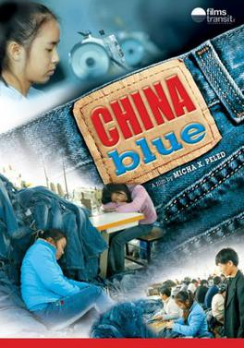
Do you know ANYONE who does not own a pair of jeans? And who thinks twice about paying upwards of $60 to several hundred dollars for a pair? Director Micah Peled takes a very close look at who is manufacturing these jeans in the hopes that he will realize consumer awareness of where clothes come from and what those who produce them endure. China Blue uncovers the inner workings of a denim factory in Shaxi, giving a first hand look at the dynamics between the laborers, owners, and the West and the high costs of the global economy.
Developed as a continuation of Peled’s 2001 production Store Wars: When Wal-Mart Comes to Town, which explores the effects of a globalized economy, Peled and his crew spent three years in China for the production of this film where the shooting was interrupted several times by the Chinese authorities, the crew was arrested and interrogated, and tapes were confiscated. The China Film Bureau put this film on its banned film list and China’s authorities harassed the featured factory owner, Mr, Kam, accusing him of collaborating with foreign media without a permit. Peled convinced Mr. Lam to participate by telling him he was to be a star of a “movie about the new generation of Chinese entrepreneurs.”
China Blue follows young teenager Jasmine Lee in her journey from her rural home to the city of Shaxi, Guangdong in hopes of financially aiding her family. There, like an estimated 130 million migrant workers on the move in China, most of the young women, she finds employment at a factory that assembles denim clothing for export to overseas markets. She shares a room with twelve other girls on the upper floor of a grim concrete dorm and labours 18 hours a day, from 8 to 2 in the morning, seven days a week, removing lint and snipping the loose threads from the seams of denim jeans. Jasmine and her friends, many of them under the age of 15, frequently work until 2 or 3 a.m. without any overtime pay and their bland daily meals are taken out of their pay. Misdemeanors such as leaving the factory without permission or sleeping during work hours result in pay cuts. The jeans Jasmine works on are headed for the United States where they will be sold in stores like Wal-Mart. For a $60 pair of jeans, the factory receives a dollar, and Kasmine gets a fraction of that, six cents an hour. Her salary averages between $30 and $60 a month.

Complete the following Pre-Viewing Film Study Questions

Questions to complete before watching the film:

- What is globalization? Is it a single process, or are there different “globalizations”?

- Who are the winners and who are the losers of Globalization?

- What has the impact of trade liberalization (neo-liberal) globalization been in the United States and Canada? Has it affected all people in the country similarly, or has it affected various groups and classes differently?

- How has the neoliberal globalization affected China? What sorts of changes have happened in China over the last 25 years? Is China a communist country? If so, what does it mean to be a communist? If not, is China capitalist?

- How do you think we can solve some of the problems that have recently been created?

You may now watch the film. Click the blue text link below!

CHINA BLUE: THE FILM

---------------------------------------------------------------------

China Blue 1A: Read the following article

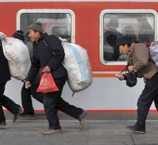

China’s Economic Reforms Likely to Increase Internal Migration

October 1, 2002
Despite the restrictions and economic penalties associated with migration in China, large numbers of rural Chinese are leaving their villages for cities and coastal provinces, and many more will likely do so now that China is a full member of the World Trade Organization (WTO).
WTO membership, which took effect in December 2001, accelerated China’s transformation into a major magnet for foreign investors eager to take advantage of low wages and a relatively well-educated and disciplined workforce. At the same time, a restructured economy means lower import barriers, reduced subsidies for farmers, privatization and streamlining of giant state enterprises, and a likelihood of increasing unemployment.
Analysts expect that these changes could see an increase in China’s already massive “floating’ population - the millions of rural people who flock to urban centers where they are not registered to live.
“Freer trade is expected to increase foreign investment in China, creating jobs in factories, but it also may speed up the movement off the land as cheaper farm products enter China,” write Philip Martin and Jonas Widgren in “International Migration: Facing the Challenge,” a report by the Washington-based Population Reference Bureau (PRB).
The migrants tend to be people between the ages of 20 and 35 who have average or above-average incomes, compared with others in their hometowns. As with international immigrants, these internal travelers are subject to demand-pull, supply-push, and other factors.
Migrants generally move from rural areas to cities, with rural laborers going from central and western regions to parts of the east coast for work in township and village enterprises and low-skilled city jobs. Dire conditions and a few jobs in villages prompt the rural exodus.
“In villages across central and southern China, incomes have stagnated,” according to an April 2001 New York Times article by Erik Eckholm. “Most young people migrate to coastal cities to perform menial jobs, and local governments are so short of money that officials and teachers often go unpaid for months at a time.”
Succession to the WTO and integration of China into the world economy increased the potential for the exodus of labor out of agriculture and into cities.
Home to more than 20 percent of the world’s 6 billion people, China, the world’s most populous nation, is a poor and predominantly rural country. The 800 million Chinese living in rural villages are much poorer than the 500 million people in the cities.
China restricts movement within the country and introduced a household registration system in the 1950s, listing everyone in a specific location, usually their place of birth. Even though the system was relaxed in 1994, conditions for internal migrants remain difficult. It is difficult for rural migrants to obtain housing, education, and government

Answer the following questions by referring to the previous article: 1A

- Why do the workers in the film want to leave the countryside? What would they do if they stayed back home?

- Many supporters of neoliberalism claim that “even if conditions in factories are bad, they are better than working the fields,” additionally stating that “it’s their choice. If they don’t like the jobs in the factories they can leave.” Is this a valid argument? Do the factory girls have a choice? Why other types of jobs do you think they could get?

- For what reasons other than just economic ones do the girls seem to want to leave the countryside? Do you know anyone from the countryside in the U.S. that moved to a city? What were some of their reasons for wanting to leave?

- What is the relationship between migrant workers and city people? Do the migrant workers tend to hang out with local city people? Why or why not?

- What sorts of social and economic problems do you think 150 million migrants moving to the cities could cause in China? How do you think the government could address this issue?

- What do you know about the process of urbanization in the U.S. or other western countries? When did this happen? What sorts of social and political issues arose in this time period? What similarities and what differences are there with the situation in present day China?

China Blue 1B: Read the following article
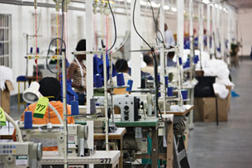

Life in Chinese Sweatshops
Many Americans have some sense that conditions for factory workers in China are quite bad. Because of extensive reports on bad conditions in Chinese factories producing for American brands, the phrase “Made in China” is often associated with sweatshops. But what are the specific problems that Chinese workers face in these factories that have been powering the economy of much of coastal China?
Perhaps most shocking to westerners is the continued use of child labor in Chinese factories. Although factories almost always demand that workers are 17 or older, fake documents are readily and cheaply available in any major Chinese city. Thus, many children as young as 14 or 15 often work in factories, and factory management is often not strict about checking the validity of workers’ documents. Child laborers tend to be more submissive, and therefore less likely to “cause problems” for management. Problems with child labor are quite evident in China Blue.
Though it varies from factory to factory, problems with occupational safety and health (OSH) are quite widespread in China’s export processing zones. In order to save on expenses, factory bosses are often reluctant to install necessary safety features, such as ventilation systems, machine guards, eye washing stations, or fire extinguishers, and many workers never receive appropriate safety training before being put on the job. The result of this has been countless unnecessary injuries such as loss of fingers, hands, and arms, as well as other threats to health caused by contact with toxic substances or overly hot work rooms.
Perhaps the most frequently heard complaint from Chinese factory workers is that their salary is too low, and often is not paid on time. Reports of employees going up to half a year without receiving wages are not uncommon, and corrupt local officials who are loathe to threaten capital accumulation are often disinclined to intervene on behalf of workers. Even when salaries are paid on time, they are often below the locally stipulated minimum wages. Many workers leave the countryside hoping to earn more money to support their families back home, but instead find out that after paying for housing, food, and clothing on a factory paycheck, they have very little to send home. Sometimes they cannot even earn enough money to buy a ticket back to the countryside, keeping them in a semi-indentured status.
Another problem that is quite evident in the film is the poor living conditions migrant workers face in factories. Factories in China generally have a compound design, where outsiders must check in with security before gaining access to the premises. Within the compound there is the factory, as well as worker cafeteria and dorms. “Good” dorms have 6-8 workers per room, and many have up to 12 or 14 workers stacked up in triple bunk beds. It is not uncommon for dozens of workers to share a single bathroom, and many dorms do not have hot water available on every floor of the dormitory. Factory workers are almost unanimous in complaining about the poor quality of the food they receive in the cafeterias, as old withered vegetables, low quality rice, and very little meat or fish is the daily fare. Workers’ salaries are too low to allow them to eat in higher priced nearby restaurants.
Finally, and perhaps most importantly, is the fact that Chinese migrant workers have no access to independent trade unions which might be able to help them fight for an improvement in conditions. The Chinese government has outlawed all independent trade unions, leaving the Communist Party controlled All China Federation of Trade Unions (ACFTU) as the only option. The ACFTU has almost no history of fighting for workers rights’ as its leaders are often appointed by the Party, and they will often appoint factory managers or government officials to run the union. As a result, workers have very little trust in the union, and largely see it as something that will not serve their interests. Until Chinese workers are able to engage in democratic forms of self-organizations, it will be difficult to improve the problems they face in the workplace.

Answer the following questions be referring to the previous article: 1B

- Everybody knows that conditions in most Chinese factories are bad. If we all know this, why do you think American companies are still willing to have their goods produced there?

- Compare the conditions for workers you saw in the film to conditions for factory workers in the United States. What is the difference? Why do you think conditions may be better in the United States?

- Do you think that so much production has been relocated to China because of, or in spite of, the bad conditions that factory workers there face?

- As already mentioned, many people argue that conditions in these factories, bad as they may be, are better than what awaits these migrants were they to return to the countryside. After watching this film, do you buy this argument? If the argument is true, does that mean that conditions should not be improved? Which problems do you think are the most pressing?

- Compare what you saw in China Blue to conditions in factories in the U.S. in the early 20th century. How are they similar and how are they different? What allowed workers in the West to secure better working conditions, higher salaries, health insurance, and a chance at entering the urban middle class during the middle part of the 20th century?

China Blue 1C: Read the Following Article


Resistance to Exploitation
According to the statistics of the Chinese Ministry of Public Security, there were 74,000 incidents of collective action in China in 2005. Even by the conservative and often politically motivated statistics of the Chinese government, incidents of protest, strikes, and all forms of labor conflict have been increasingly rapidly over the past several years. Although many different sectors of Chinese society have been increasingly willing to take part in collective action, workers in privately owned factories, such as the one in China Blue, have been one of the most active groups.
There is of course no single reason why Chinese workers have been increasingly quick to engage in forms of collective direct action. However, many of the problems already mentioned are generally behind incidents of protest, with workers generally most willing to take action over unpaid wages. Tactics that workers use include slowdowns, full strikes, road blockages, and even threatening suicide.
Of course, engaging in collective action can be quite dangerous for Chinese workers. In 1982, the Chinese government abolished workers’ right to strike, meaning each time that workers walk off the job, they are breaking the law. As already mentioned, it is illegal for Chinese workers to establish democratic independent unions. Any extensive form of independent organization is immediately crushed when discovered by the state, and activists risk being fired or imprisoned. As can be seen from the example of Mr. Lam, often times factory bosses are former government officials or they have good connections with those in the state bureaucracy. Lack of democratic procedure and transparency allows many local officials to engage in serious corruption, and so they are often willing to overlook breaches of the law on the part of factory owners. This same phenomenon makes these officials intolerant of any attempt of workers to stand up for their own rights, and worker activism is thus generally met with severe repression.

Answer the following questions by referring to the previous article: 1C

- What were the reasons that the workers in the movie engaged in collective action? Do you think there was a positive outcome?

- Imagine you were a worker in the factory in China Blue. Would you be willing to risk getting fired to participate in the action? Why or why not?

- Do you think that walking off the job was a good decision for the workers? What other options might have been available to them?

- How was the resolution of this labor dispute similar or different from how labor disputes are resolved in the United States? What do you think American workers would have done if they encountered a similar problem? Why do you think the process might be different here than it is in China?

China Blue 1D: What Can We Do?

The anti-sweatshop movement that has developed over the past ten years in the United States and Europe has demanded that Western brands purchase goods from socially responsible producers, even if the producers are located in the global South. The movement started on university campuses, with student activists demanding that their schools only license “sweat-free” apparel. After a series of very public attacks on conditions in supplier factories of many high profile western brands, these corporations have responded by promoting “corporate social responsibility” (CSR), which aims to address consumers’ concerns about conditions for factory workers.
The results of nearly a decade of anti-sweatshop activism have been mixed. Many big companies have adopted somewhat more transparent sourcing systems (eg. Nike), and conditions have improved in a select number of cases. However, particularly in China, a CSR approach to improving workers’ conditions has largely been a failure. Corporations have responded to allegations of unethical treatment of workers by establishing a convoluted system of social codes of compliance that is backed up by factory auditing. However, auditing is often not conducted by an independent entity, coaching workers on the appropriate answers to give in interviews. Even when western corporations claim that they have good social codes of compliance, it is very rare that they are adequately enforced. Finally , and perhaps most significantly, corporate codes of conduct almost never include requirements for democratic and independent worker representative bodies in the workplace.
An additional obstacle to achieving the humane treatment of workers n China has been western brands’ unwillingness to pay higher prices for social compliance from supplier factories. This then puts suppliers, like Mr. Lam, in a difficult position: corporations demand that he pays higher wages, uses less overtime, install better health and safety facilities, and yet they are unwilling to increase the purchasing price. In the cutthroat Chinese marketplace, suppliers have very small profit margins, and this “dual pressure” of demands for low prices and demands for social compliance often leaves local producers in a difficult position.
Given that codes of conduct are rarely adequately enforced, this leaves consumers wishing to purchase ethically-produced goods in something of a bind. Corporations of course would like this problem to go away, and if they can avoid public relations scandals, the problem is solved for them. But the truth of the matter is, a factory-auditing approach to ensuring humane working conditions is almost always bound to fail. The only way that we can be sure that workers are being treated in a way that conforms to a high standard of morality and social justice is when workers are able to form democratic and independent representative bodies, such that they can defend themselves. If this were to happen, there would of course be no need for the paternalistic factory audits that we presently have.
What then, can we as concerned Americans do to help Chinese workers like Jasmine and her friends? Well, the first, somewhat counter-intuitive response is to join a union here and push them to support solidarity work in China. As is clear from the film, Chinese workers are not the enemy of American workers; rather it is transnational corporations who lay off American workers only to depend on the sweatshop labor of Chinese migrants that are the real criminals. Building a strong labor movement in America that sees Chinese workers as compatriots, rather than as enemies, will be key to building a workers’ movement in China. Secondly, though perhaps less likely to succeed, we can push western companies to demand that all supplier factories have democratic worker representative bodies, and that management be willing to engage in collective bargaining. As already mentioned, if Chinese workers have their own voice in the workplace, there will be no need for the largely ineffectual outside auditors. Finally, and most importantly, is pushing for increased government regulation of labor relations. Unfortunately, in the current neo-liberal environment, governments around the world are less and less willing to regulate labor relations and labor markets, as policies bow to the ever increasing demands of transnational capital. However, if we can pressure governments at home and abroad to step up in defense of workers’ rights, this is of course the best solution. When the state guarantees that all workers will be treated decently, there will be no need to worry about ethical consumerism.

Answer the following questions by referring to the previous article: 1D
- What do you think “corporate social responsibility” means? Can corporations simultaneously be socially responsible and make a profit? How so?

- Who do you think is more responsible for the bad conditions in the factory in the movie, Mr. Lam the manager, or the foreign purchasers? Who do you think has more power to improve things for the workers?

- Is a company’s record on social compliance an important factor when you make purchasing decisions? Where do you get your information? Do you think it’s reliable?

- Are you willing or able to spend more money on “sweat-free” clothing? Do you think most people in America are?

- What stance do you think the American labor movement should take towards Chinese workers? How do you think we can build real solidarity between American and Chinese workers?

- Why do you think governments around the world are afraid to do anything to “damage the investment environment,” eg. give workers greater legal protections? Do you think there is a way out of the so-called “race to the bottom”? How can we pressure our government to try to stop this vicious cycle?

China Blue 1E: Is Neoliberal Globalization Improving People’s Lives?
One of the primary claims of supporters of neoliberal policies within China and other countries is that the free market will necessarily produce an improvement in the lives of a majority of the population, even if it results in an initial growth in inequality. Whether conceptualized as “trickle-down economics” or the Clintonian metaphor of a rising boat lifting all ships, this logic holds that inequality should be tolerated since all social classes are experiencing upward socioeconomic mobility. Adherents to free market ideology believe that neoliberal globalization is a win-win game: countries in both the developed global North and in the developing global South can benefit.
However, the results over the past 20+ years of free market expansion have been decidedly mixed. China and India are often cited as the best examples of the success of globalization. Indeed, the economic reforms in China have lifted tens of millions of people out of poverty and led to the creation of a large and increasingly wealthy middle class in urban areas. Mr. Lam, the factory owner from the movie, is a perfect example of someone who was able to secure an incredible improvement of material comfort in the span of just a few years. However, the luster of the Chinese economic “miracle” has been tempered by out of control growth in levels of inequality that has lead to fears of social instability. President Hu Jintao’s promotion of constructing a “harmonious society” is the government’s attempt to address some of the shortcomings of the economic reforms. Whether the Chinese bureaucracy, as enmeshed in the process of capital accumulation as it is, can be mobilized against business interests has yet to be seen.

Answer the following questions by referring to the previous article: 1E
- Working in export processing factories such as the one in China Blue was not an option for rural Chinese only 20 years ago. Because of the restructuring of the rural economy, young Chinese are often forced to seek work in the cities. Do you think that the economic reforms have improved the lives of Jasmine and her friends?

- Clearly, the economic reforms have benefited Mr. Lam more than they have the factory workers. Do you think this sort of inequality is acceptable or does it invalidate the success of the economic reforms?

- Do you think that the inequalities that are growing in both China and the United States are temporary, or is it a permanent feature of free market economics? What sorts of policy initiatives do you think would be effective in making economic growth more equitable?

- What have been the effects of neoliberal globalization in the United States? What sorts of jobs have been gained here, and what sorts have been lost? What about in China? Are the jobs being created in the U.S. good jobs? What about the ones in China?

- Based on what you’ve seen in the movie, why do you think so many companies want to relocate factories to China? How are factory jobs in China different than they are in the U.S.? Sometimes companies say that even if they have to lay off workers in the U.S. to relocate to China, they are helping Chinese workers in the process. Do you think this is true?

-------------------------------------------------------------------------------------
Watch the following video called The Story of Stuff. Then complete the assignment. Click on the blue link below!

THE STORY OF STUFF LINK:
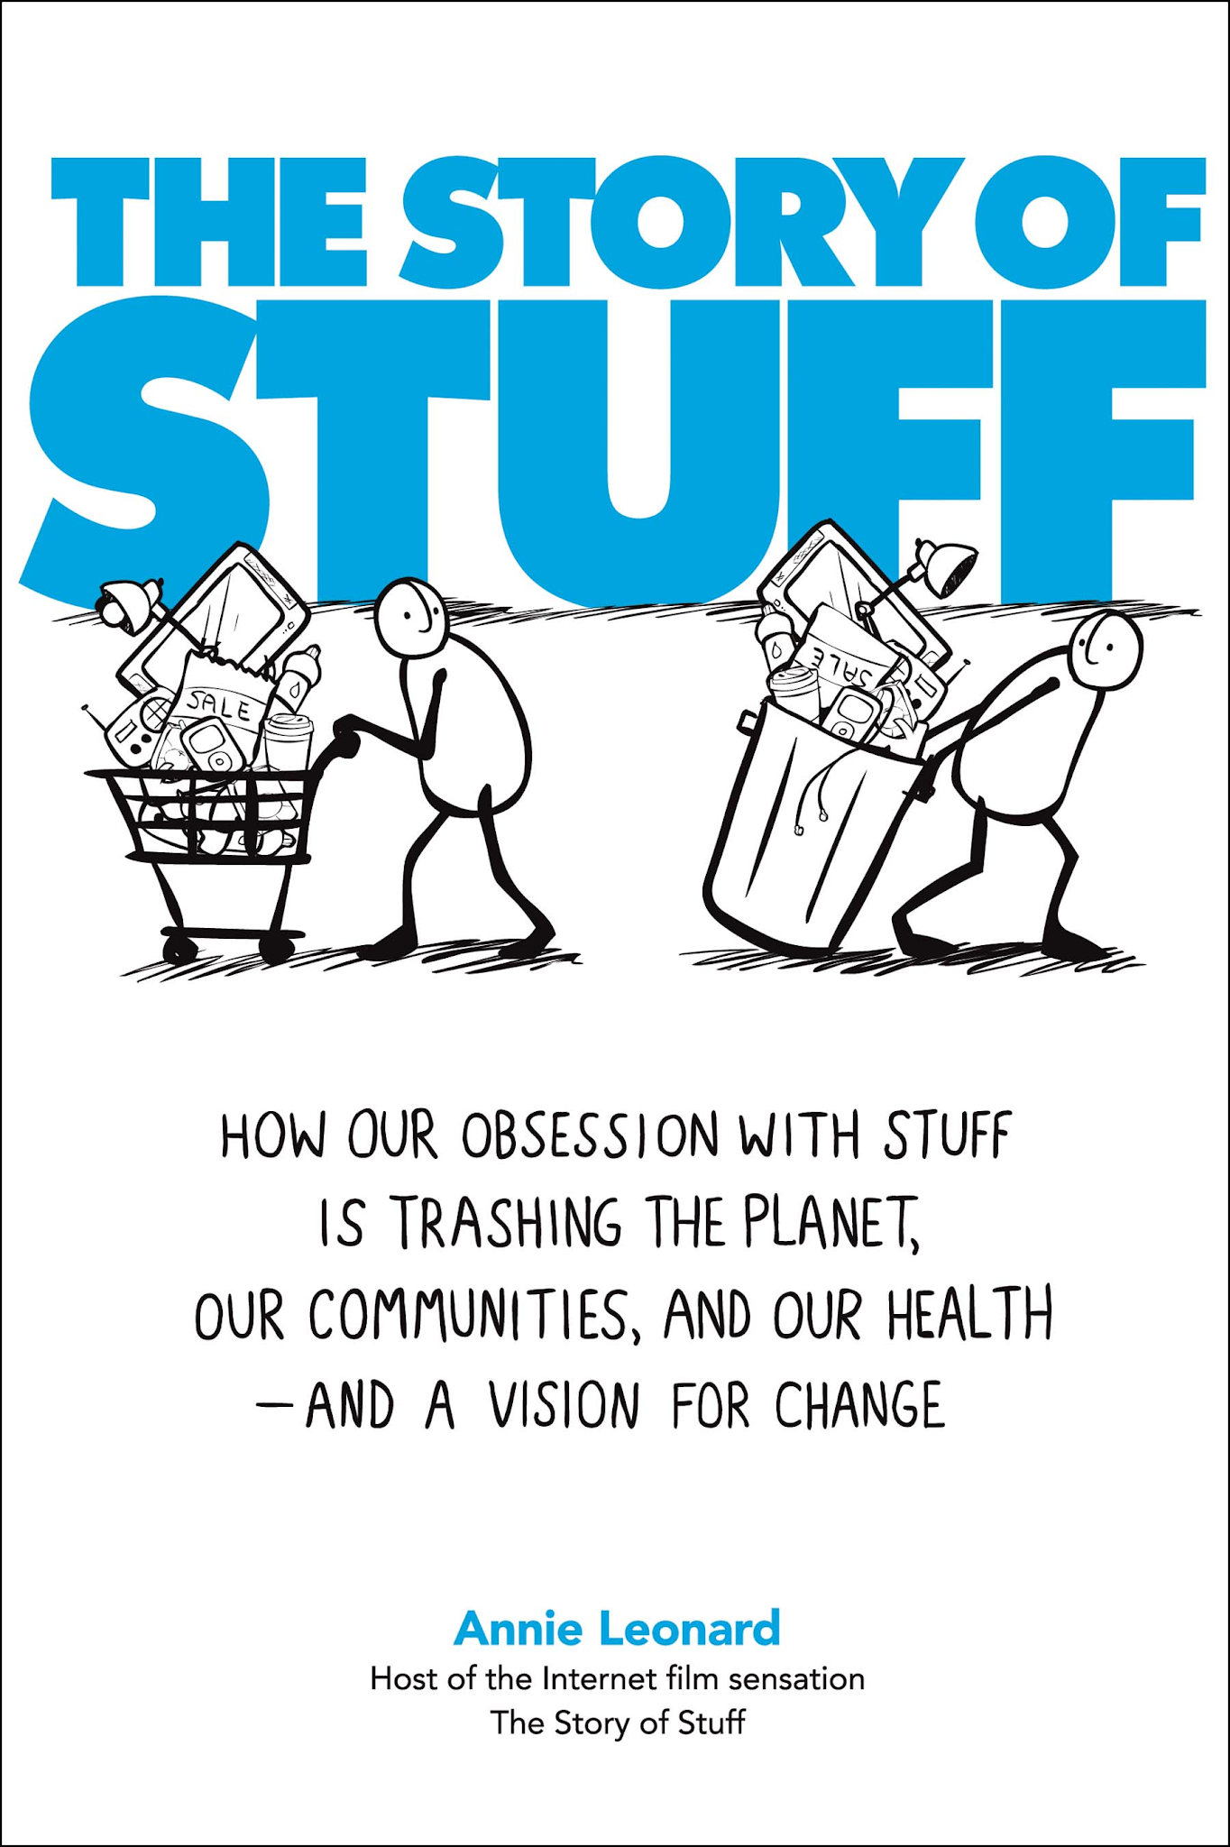

“The Story of Stuff” Worksheet

After you’ve watched “The Story of Stuff” with Annie Leonard, answer the following questions to check your listening and understanding:

1. Copy the sketches of the 5 stages of the materials economy
Extraction | Production | Distribution | Consumption | Disposal

2. How much of our natural resources have been trashed in the last few decades?

3. How many planets are needed to support current rates of consumption in the US and Australia?

4. How many trees are being lost in the Amazon each minute?

5. What is being added to the production system that creates dangerous waste products?

6. What food is at the top of the food chain and threatening the health of future generations?

7. What is meant by “externalising costs of production”?

8 Who is paying for the real cost of cheap electronic equipment (i.e. the $4.99 radio)? List three groups at least.

9a. How much material is still in the system after 6 months?____________%.

9b. Where have the remaining materials gone?

10. When did the modern consumer economy come into being? Why?

11. According to Annie Leonard, what are some of the social and community interests being neglected while we are busy consuming “stuff”?

12. What do these terms mean? Give an example of each.

- “planned obsolescence”

For example

- “perceived obsolescence”

For example

13a. What is happening to the levels of measured happiness?

13b. What reasons are given?

14. Summarize the steps in the treadmill.

15. One solution which many countries use to deal with increasing waste is to burn it. What problem is associated with burning waste?

16. How does recycling help?

17. Why is recycling not enough? (Clue: How many trash bins are needed to produce one bin of recycled materials?)

FakeOut

FakeOut is an e-learning interactive that aims to build the habits for verifying information online. Through claim and source evaluation, students learn how to distinguish true from false information on the internet - in the game and in real life.
Click here to play FakeOut!
When you have completed the final activity, please take a screenshot of your results and submit it to the text box below.

Insert your image here!

Watch: One Man
Listen to the lyrics. What are you final thoughts on our world and the things you have learned?

You have now reached the end of your module. Submit your module to Brightspace and email your instructor for feedback.

